DISPLAY SCREEN EQUIPMENT

WORKSTATION RISK ASSESSMENT

Department:
Location and Identification of Workstation:
Personnel Involved:
Assessed by (Print Name)
Assessment approved by (Print Name)
Signature, Date
Date for Next Scheduled Review:
Date of Most Recent Review:
Actions to be taken:

DISPLAY SCREEN EQUIPMENT WORKSTATION RISK ASSESSMENT

Risk Factors |  |  |  | Things to consider | Action to take
 | Yes | No
1. Display Screens
Are the characters clear and readable?  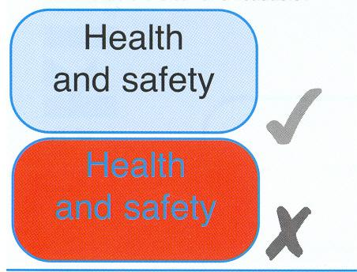 |  |  |  | Make sure the screen is clean and cleaning materials are made available
Is the text size comfortable to read |  |  |  | Software settings may need adjusting to change text size
Is the image stable, free of flicker and jitter |  |  |  | Try using different screen colours to reduce flicker, eg darker backgrounds and lighter text.  If problems still exist , get the set-up checked, eg by the equipment supplier
Is the screen’s specification suitable for its intended use |  |  |  | For example, intensive graphic work or work requiring fine attention to small details may require large display screens
Are the brightness and/or contrast adjustable |  |  |  | Separate adjustment controls are not essential , provided the user can read the screen easily at all times
Does the screen swivel and tilt  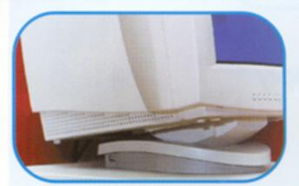 |  |  |  | Swivel and tilt need not be built in; you can add a swivel and tilt mechanism.  However you may need to replace the screen if:  - Swivel/tilt is absent or unsatisfactory  - Work is intensive; and/or  - The user has problems getting the screen to a comfortable position
Is the screen free from glare and reflections  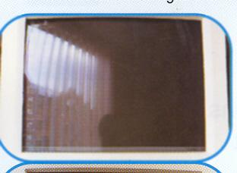  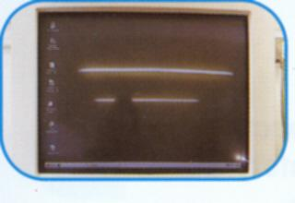 | Yes | No |  | Use a mirror placed in front of the screen to check where reflections are coming from.  You might need to move the screen or even the desk and/or shield the screen from the source of reflections.  Screens that use dark characters on a light background are less prone to glare and reflection
Are adjustable window coverings provided and in adequate condition |  |  |  | Check that blinds work. Blinds with vertical slats can be more suitable than horizontal ones.  If these measures do not work, consider anti-glare screen filters as a last resort and seek specialist help.
2. Keyboards
Is the keyboard separate from the screen |  |  |  | This is a requirement, unless the task makes it impracticable (eg where there is a need to use a portable)
Does the keyboard tilt |  |  |  | Tilt need not be built in
Is it possible to find a comfortable keying position  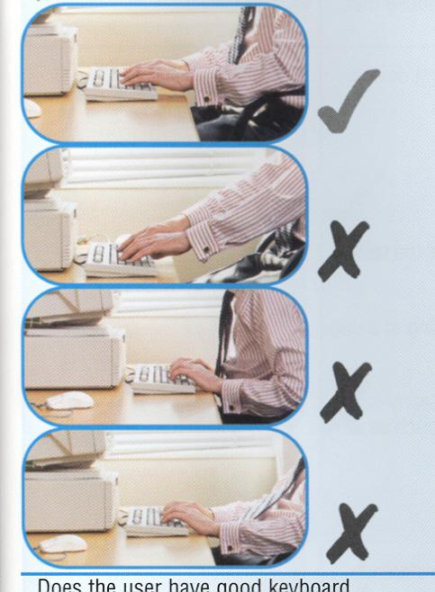 |  |  |  | Try pushing the display screen further back to create more room for the keyboard, hands and wrists.  Users of thick raised keyboards may need a wrist rest.
Does the user have a good keyboard technique | Yes | No |  | Training can be used to prevent:  - Hands bent up at wrist  - Hitting the keys too hard  - Overstretching the fingers
Are the characters on the keys easily readable |  |  |  | Keyboards should be kept clean. If characters still can’t be read, the keyboard may need modifying or replacing.
3. Mouse, trackball etc
Is the device suitable for the tasks it is used for |  |  |  | If the user is having problems, try a different device. The mouse and trackball are general-purpose devices suitable for many tasks, and available in a variety of shapes and sizes. Alternative devices such as touchscreens may be better for some tasks (but can be worse for others)
Is the device positioned close to the user  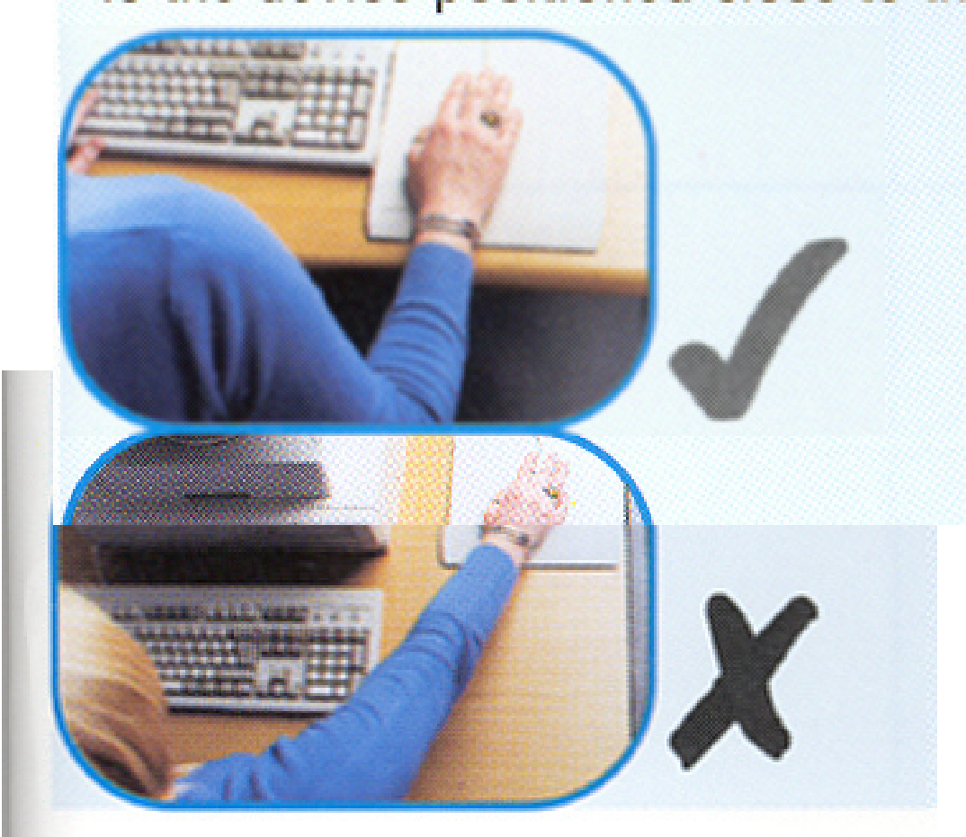 |  |  |  | Most devices are best placed as close as possible eg right beside the keyboard.  Training may be needed to:  - Prevent arm overreaching  - Tell users not to leave their hand on the device when it is not being used;  - Encourage a relaxed arm and straight wrist
Is there support for the device user’s wrist and forearm |  |  |  | Support can be gained from, for example, the desk surface or arm of a chair. If not, a separate supporting device may help.  The user should be able to find a comfortable working position with the device
Does the device work smoothly at a speed that suits the user |  |  |  | See if cleaning is required (eg of mouse ball and rollers). Check the work  surface is suitable. A mouse mat may be needed.
Can the user easily adjust software settings for speed and accuracy of pointer | Yes | No |  | User may need training in how to adjust device settings
4. Software
Is the software suitable for the task |  |  |  | Software should help the user carry out the task, minimise stress and be user-friendly.  Check users have had appropriate training in using the software  Software should respond quickly and clearly to user input, with adequate feedback, such as clear help messages.
5. Furniture
Is the work surface large enough for all the necessary equipment, papers etc  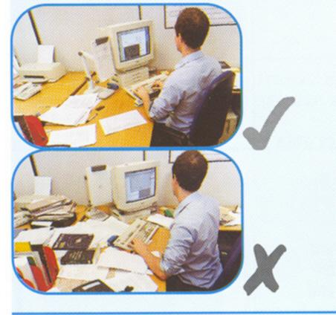 |  |  |  | Create more room by moving printers, reference materials etc elsewhere.  If necessary, consider providing new power and telecoms sockets, so equipment can be moved.  There should be some scope for flexible re-arrangement
Can the user comfortably reach all the equipment and papers they need to use |  |  |  | Re-arrange equipment, papers etc to bring frequently used things within easy reach.  A document holder may be needed, positioned to minimise uncomfortable head and eye movements
Are surfaces free from glare and reflection |  |  |  | Consider mats or blotters to reduce reflections and glare
Is the chair suitable  Is the chair stable  Does the chair have a working:  - Seat back height and tilt mechanism  - Seat height adjustment  - Swivel mechanism  - Castor or glides | Yes | No |  | The chair may need repairing or replacing if the user is uncomfortable, or cannot use the adjustment mechanisms
Is the chair adjusted correctly  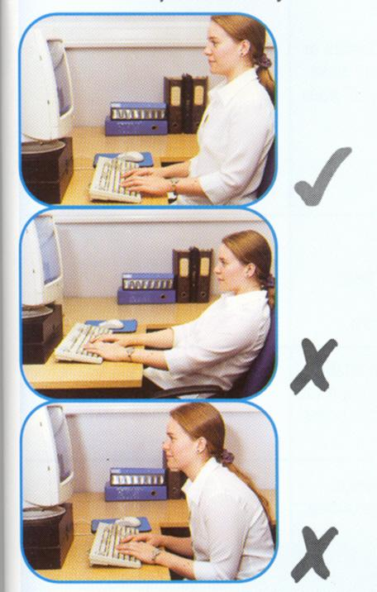 |  |  |  | The user should be able to carry out their work sitting comfortably.  Consider training the user in how to adopt suitable postures while working.  The arms of chairs can stop the user getting close enough to use the equipment comfortably.  Move any obstructions from under the desk
Is the small of the back supported by the chair’s backrest |  |  |  | The user should have a straight back , supported by the chair, with relaxed shoulders
Are forearms horizontal and eyes at roughly the same height as the top of the VDU |  |  |  | Adjust the chair height to get the user’s arms in the right position, then adjust the VDU height, if necessary
Are feet flat on the floor, without too much pressure from the seat on the backs of the legs |  |  |  | If not, a foot rest may be needed
6. Environment
Is there enough room to change position and vary movement | Yes | No |  | Space is needed to move, stretch and fidget.  Consider reorganising the office layout and check for obstructions.  Cables should be tidy and not a trip or snag hazard
Is the lighting suitable, eg not too bright or too dim to work comfortably  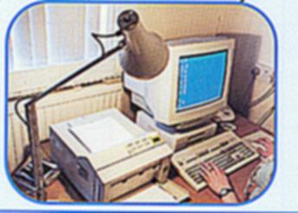 |  |  |  | Users should be able to control light levels, eg by adjusting window blinds or light switches.  Consider shading or repositioning light sources or providing local lighting, eg desk lamp (but make sure lights don’t cause glare by reflecting off walls or other surfaces)
Does the air feel comfortable |  |  |  | VDUs and other equipment may dry the air.  Circulate fresh air if possible. Plants may help.  Consider a humidifier if discomfort is severe.
Are levels of heat comfortable  Are levels of noise comfortable? |  |  |  | Can heating be better controlled? More ventilation or air-conditioning may be required if there is a lot of electronic equipment in the room. Or, can users be moved away from the heat source?  Consider moving sources of noise, eg printers away from the user. If not, consider soundproofing
7. Final questions to the users….
- Has the checklist covered all the problems they may have working with their VDU  - Has the user experienced any discomfort or other symptoms which they attribute to working with their VDU (if there is a yes answer further action must be taken)  - Is the user aware of their entitlement to eye and eyesight testing  - Does the user take regular breaks working away from the VDUs  - Has the user been given adequate VDU health and safety training  - Has the user been shown, or is aware, how to adjust furniture (eg seat height and seat back height and tilt) | Yes |  | No

DISPLAY SCREEN EQUIPMENT ASSESSMENT SCHEDULE

Assessments must be completed of the workstations of those identified as “users” and for the display screen equipment used by employees. Other workstations should be of a similar standard so far as is reasonably practicable.

Workstation | Assessor | Completion Date | Review Date

