Element | Expected result | Actual result | Action
Navigation links | Links take the user to the correct page | As expected | none
Images | All images display correctly | As expected | none
Buttons | Buttons take the user to the correct page or show if quiz answers are correct and display score | The button to check if an answer is correct for some questions is not working | Check the code to see if all of the buttons to check answers are labelled with the correct id for the questions where the buttons aren’t working.
Layout | Layout is consistent on each page | As expected | none
Quiz | User is able to input answers and see if the answer is correct or incorrect and check score | Some answers are displaying as incorrect when they are correct. Score is not increasing on some pages. | Look over the code and make sure that the answers are stored correctly and the score increases after every correct answer.

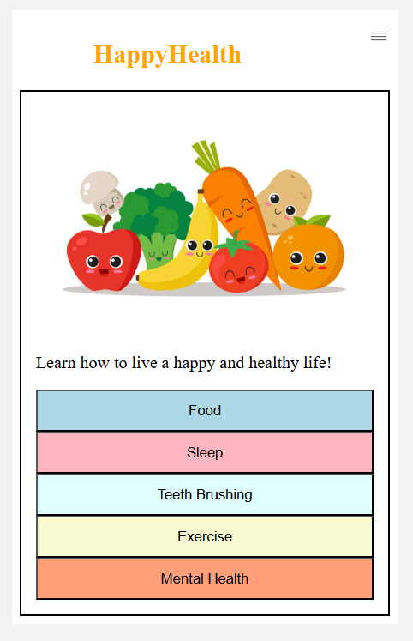
Element | Expected result | Actual result | Action
Navigation links | Links take the user to the correct page | As expected | none
Images | All images display correctly | As expected | none
Buttons | Buttons take the user to the correct page or show if quiz answers are correct and display score | As expected | none
Layout | Layout is consistent on each page | As expected | none
Quiz | User is able to input answers and see if the answer is correct or incorrect and check score | As expected | none

