Name – HappyHealth
Type – Web application
Purpose – To educate children on healthy living habits like healthy eating, brushing teeth, exercise, sleep, and mental health.
Target Audience – Children aged between 5-8 years old.
Resources | Reason
laptop | To create the app
Lucidchart | To design the wireframe for the app
WordPress | To design the app for mobile
Visual Studio Code | To code the app
Main image | For the homepage
Food image | For the food page
Sleep image | For the sleep page
Teeth brushing image | For the teeth brushing page
Exercise image | For the exercise page
Mental Health image | For the mental health page
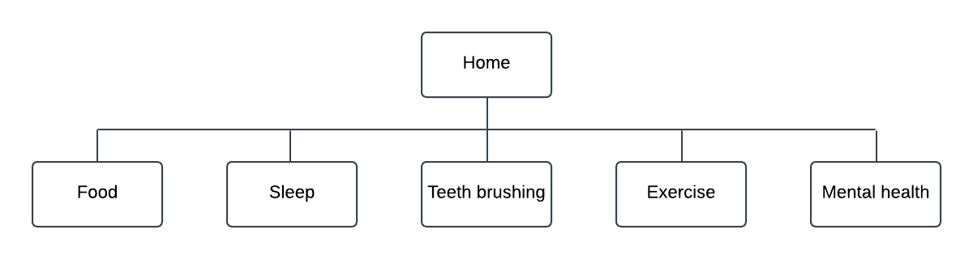
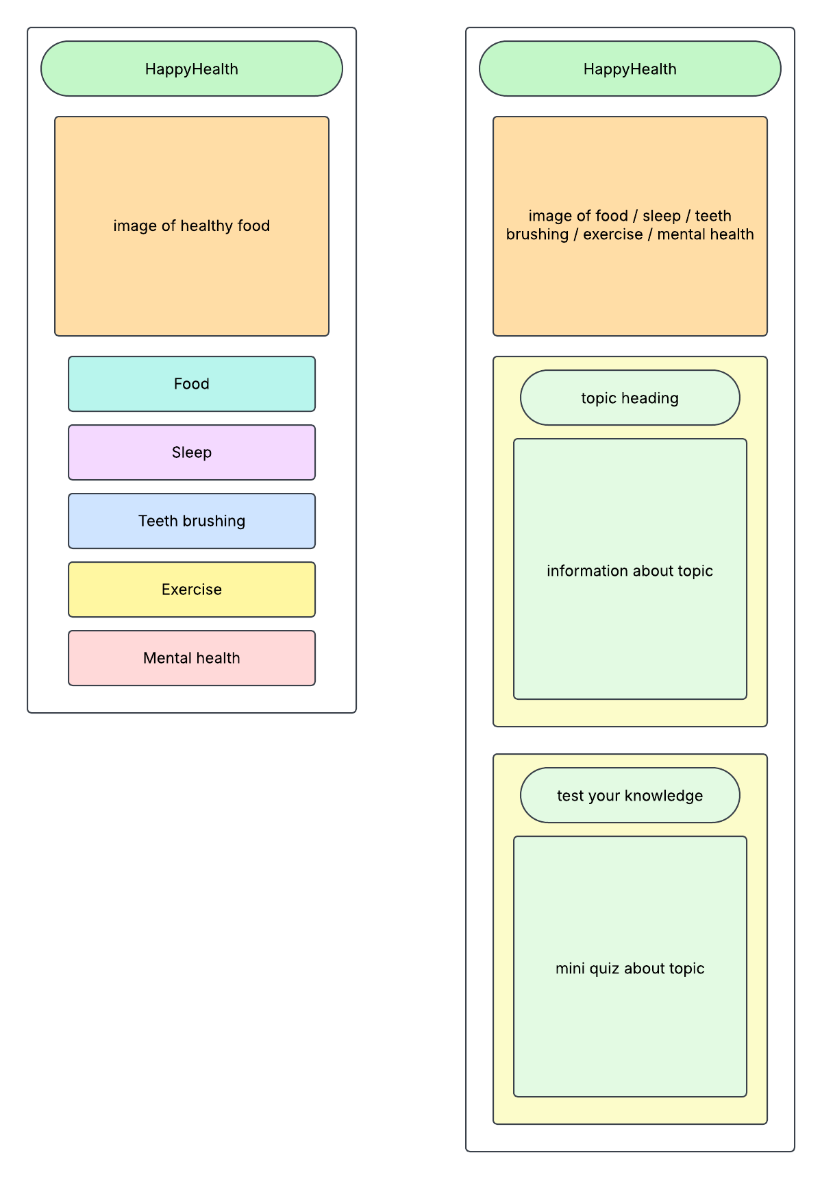

I have chosen to design a multimedia educational app for school children. The purpose of the app is to educate them on healthy living habits. I have chosen to name the app HappyHealth. The target audience for my app is children aged between 5-8 years old since they are able to read. My app will have lots of pictures to make it engaging for the younger audience. On the home page, I will have a large simple image of healthy food that is colourful. I will also have colourful buttons labelled with the five healthy living topics that will take the children to the pages with information on each topic. The healthy living topics that I have chosen for my app are food, sleep, teeth brushing, exercise, and mental health. On the food page, I will have a simple image of healthy food like fruit. I will then have simple, bulleted information about the topic like eating enough fruit and vegetables and eating a balanced diet. I will include small pictures next to the information and make the words easy to read so that the younger children are able to understand and so it is engaging. I will then add a mini quiz with pictures so the children can test their knowledge of the information above. For the sleep page, I will have a colourful image of a bed and information like how many hours sleep the children should be getting each night. For the teeth brushing page, I will include an image of a toothbrush and information like how many times a day the children should be brushing their teeth. For the exercise page, I will include a simple image of exercise equipment and information like what exercises the children could be doing and how often. For the mental health page, I will include a colourful image of a mind and information like what to do when they feel stressed or worried. Each page will have a simple quiz at the end with questions relating to the information. The quiz will output the children’s score out of 5. There will be a button to take them back to the homepage so that they can look at the pages for the other topics after each one.

